**Blood Flow Detection and Monitoring Using Sensory Data**

**Problem Statement**

The flow of blood reveals huge information about health and has a range of useful applications like in beauty industry and sports. As its analysis will help people to stop activities that creates hinderance in blood flow. This can be done by use of sensors equipped with optical sensors, analog signal processing unit, digital signal processing unit, storage and display device. Since it increases the weight of the device and requires more energy. So, to solve this problem all the processing task has been shifted on the smartphone/laptop device and used sensors just for sensing, amplification, filtering and transmitting data to smartphone/laptop for analysis. However, the received signals are affected by the motion artifact and ambient light and received signals might have several fluctuations. Though hardware technologies are advancing we need of advancement in software techniques.

**Background**

Tissues health can be determined using blood flow analysis. Increase in blood flow can be an indicator of infection or inflammation and its decrease can indicate heart failure, diabetes or atherosclerosis. The sensor can be used to detect the blood flow. The soft skin sensing devices are composed of thermal sensors. These sensors sense the flow and can also generate little heat to get the response signal detected by other sensors. After that, the sensed values are sent to the computer that calculates the velocity of blood flow.

These soft skin sensor devices are a tiny heat pad surrounded by a ring of sensors. These are painted onto a silicon skin. These surrounded sensors are used to detect the flow, vein size. Collecting data from these wearable devices 24/7 is the area under research.

Research is also being done on some tiny implantable chip to monitor blood and send data.

Some wearable devices have been developed to monitor flow during exercise and used short Term Fourier Transform for analyzing the signals. They analyzed that blood flow at forehead was mild and at the earlobe, it was sudden at the beginning and end of running. However, the measurements at earlobe were affected by shear deformation of skin because of running and those from fingertip and forehead was unaffected by motion artifact. So, forehead and fingertip can be the candidate for taking measurements.

After collecting the values from body sensor, the analysis is done on those retrieved value to provide meaningful and required knowledge like the health of the patient. Real-time monitoring is required for instant alert. Some researchers have provided interval skip list for efficient monitoring. Some researchers have worked on handling noisy and missing values. As missing data might result in false analysis and can be handled by canonical correlation-based k-weighted angular similarity method.

**Methodology**

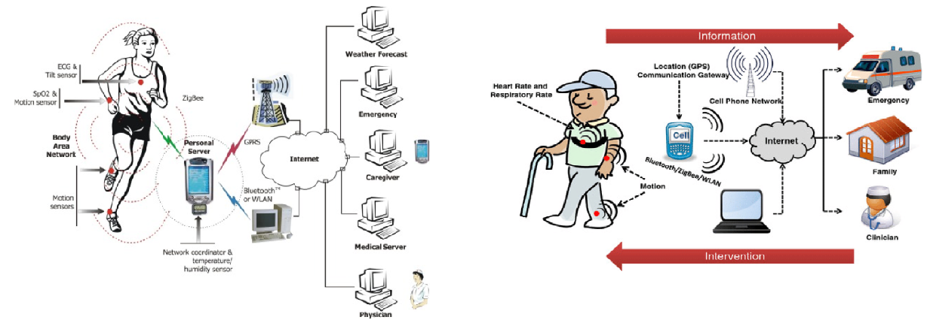

Fig1: Collection of different sensor data on mobile application or doctor’s laptop [1], [2].

Noisy signals at receiver end can be handled by passing them through low pass filter to remove high frequency noise and then pass them through autocorrelation unit to avoid non-periodic components as proposed in literature and then interpreting the signals and handling missing values and fluctuating values and determine the actual health by analysis of different sensors values by developing a processing application.

Process Noisy Signal

Apply Low Pass Filter

Auto Correlation

Interpret signal

Determine Flow Direction

Handling Missing data and fluctuations

Analysis on mobile Application

**Software**

Arduino IDE

Statically Analytical Tools

**Hardware**

* Some market available health sensors like heart rate monitor, blood pressure monitor, Motion, temperature sensors
* Wifi module
* Mobile/Laptop

**References**

1. http://www.ece.uah.edu/~jovanov/whrms/
2. Shyamal Patel, Hyung Park, “A review of wearable sensors and systems with application in rehabilitation”, Journal of NeuroEngineering and Rehabilitation 2012, 9:21